

“**Experiment 3.1”**

**Student Name: SUMIT KUMAR UID: 20BCS8226**

**Branch: CSE Section/Group: DM-720 A**

**Semester: 6th Date of Performance: 01-05-23**

**Subject Name: Data Mining Lab Subject Code: 20CSP-376**

**Aim:**

To perform the hierarchical clustering using R programming.

**Theory:**

For computing hierarchical clustering in R, the commonly used functions are as follows:

* **hclust** in the stats package and **agnes** in the cluster package for agglomerative hierarchical clustering.
* **diana** in the cluster package for divisive hierarchical clustering.

We will use the Iris flower data set from the datasets package in our implementation. We will use sepal width, sepal length, petal width, and petal length column as our data points. First, we load and normalize the data. Then the dissimilarity values are computed with dist function and these values are fed to clustering functions for performing hierarchical clustering.

**Code:**

# Load required packages

library(datasets) # contains iris dataset

library(cluster) # clustering algorithms

library(factoextra) # visualization

library(purrr) # to use map_dbl() function



# Load and preprocess the dataset

df <- iris[, 1:4]

df <- na.omit(df)

df <- scale(df)

# Dissimilarity matrix

d <- dist(df, method="euclidean")

d

# Hierarchical clustering using Complete Linkage

hc1 <- hclust(d, method = "complete")

# Plot the obtained dendrogram

plot(hc1, cex = 0.6, hang=-1)

# Cut tree into 3 groups

sub_grps <- cutree(hc1, k=3)

# Visualize the result in a scatter plot

fviz_cluster(list(data = df, cluster = sub_grps))

# Plot the obtained dendrogram with

# rectangle borders for k clusters

plot(hc1, cex = 0.6, hang=-1)

rect.hclust(hc1, k = 3, border=2:4)

# Compute divisive hierarchical clustering

hc3 <- diana(df)

# Divise coefficient

hc3$dc

# Plot obtained dendrogram

pltree(hc3, cex = 0.6, hang = -1,

main = "Dendrogram of diana")

**OUTPUT:**



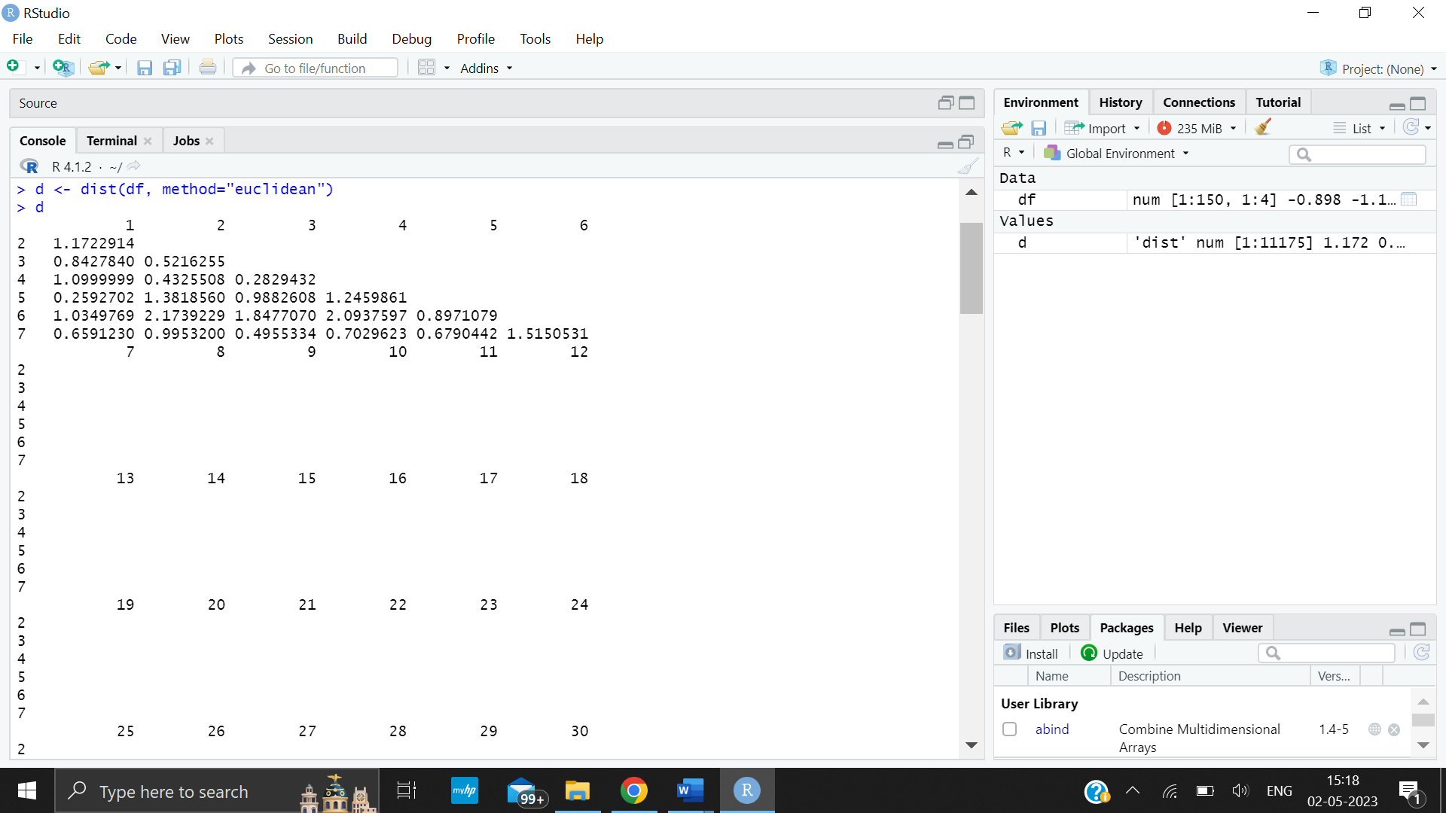

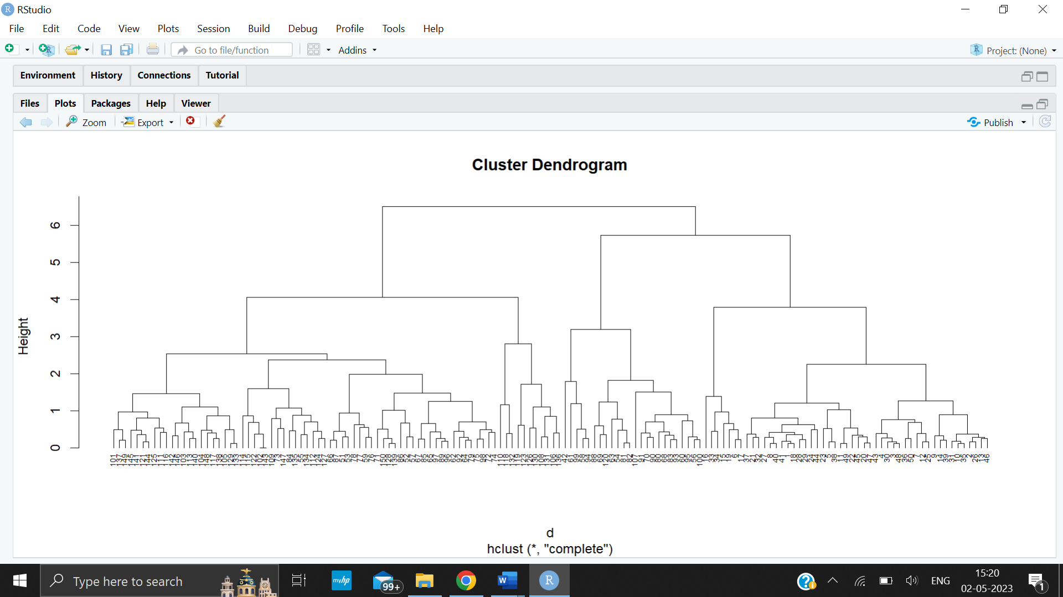



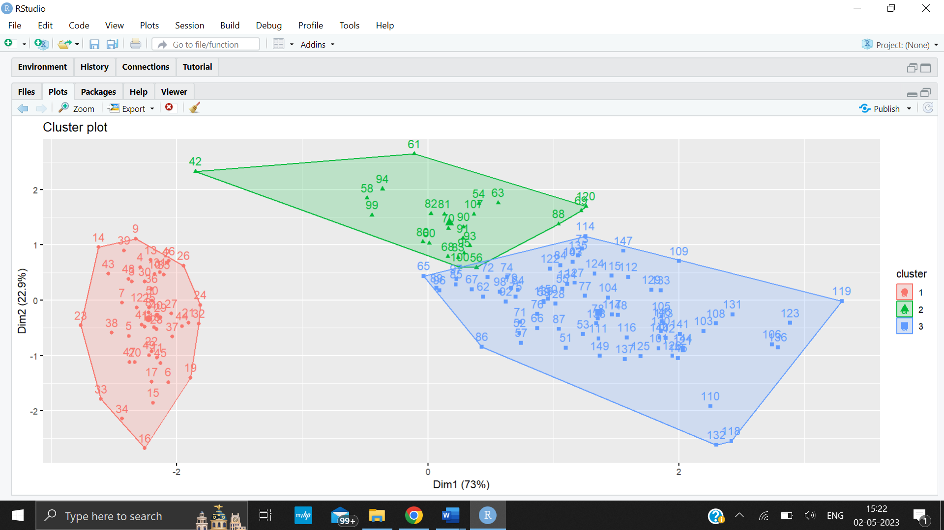

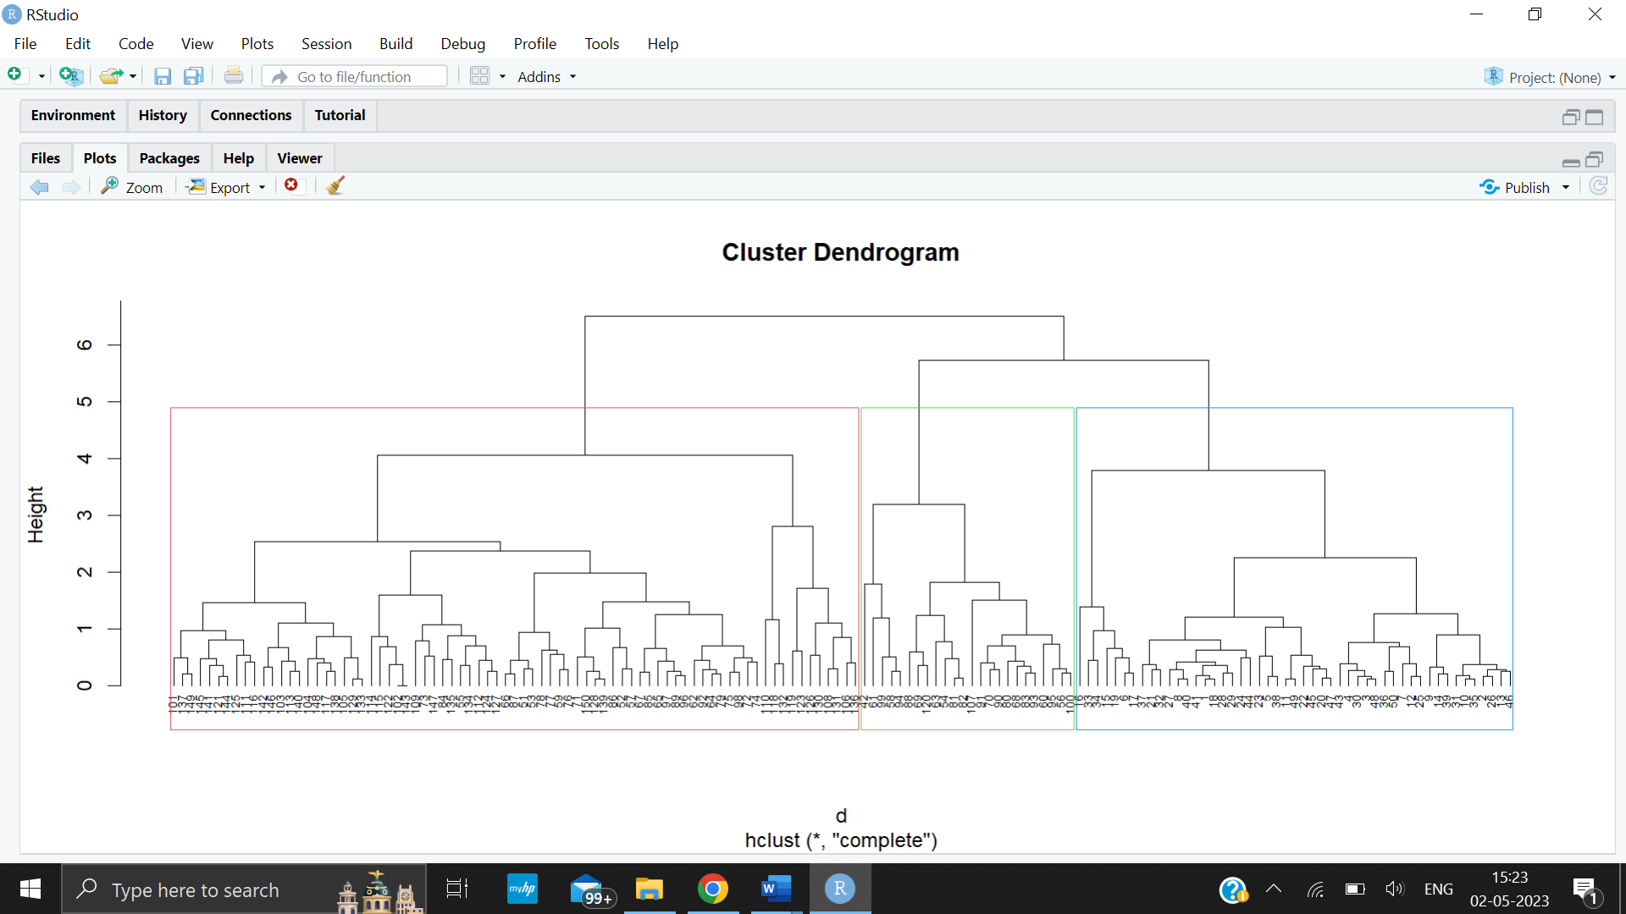



Output : [1] 0.9397208

